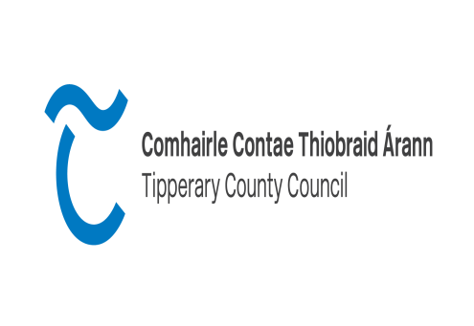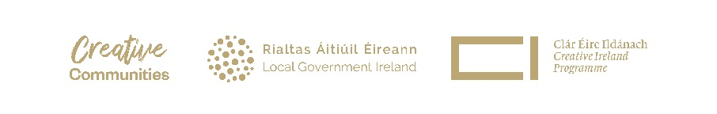

**County Tipperary**

**Creative Ireland Project Award 2025**

The Creative Ireland programme is a **culture based** programme which was created in 2017 following on from the hugely successful ‘Ireland 2016’ initiative which celebrated the hundredth anniversary of the Easter Rising. The vision of the Creative Ireland Programme 2023 - 2027 is to mainstream culture and creativity in the life of the nation so that individually and collectively, in our personal lives and in our institutions, we can realise our full creative potential thereby promoting individual, community and national wellbeing.

The Creative Ireland Programme will deliver through collaboration and partnership promoting understanding and appreciation of the value of creativity in all its forms – whether through the arts, culture, heritage, or technology.

**The Strategic Priorities for the Tipperary Creative Ireland programme 2023 - 2027 are:**

1. **Our Peoples Creativity** - to nurture creativity across the county, foster relationships between creative practitioners & communities, provide opportunity for creative engagement & promote inclusivity in access to participation in cultural activity.
2. **Our Creative Economy** - the key goal of this priority is to support creative activities which have an economic impact e.g. our creative industries. We welcome applications which may feature fashion, design, digital gaming, crafts etc.
3. **Our Creative Place** - a sense of place is central to our priorities, in terms of knowing our culture, landscape and environment which connects spaces, places and people. We welcome applications from archaeologists, historians/archivists, creatives which focus on culture and heritage.
4. **Creative Climate Action** – to focus on projects which have a climate action element to collectively address these issues.

The Tipperary Culture & Creativity Strategy 2023 – 2027 is available to access at this link on our website:

[**https://www.tipperarycoco.ie/arts-and-culture/creative-ireland-programme**](https://www.tipperarycoco.ie/arts-and-culture/creative-ireland-programme)

We are delighted to be in a position again this year to invite applications from eligible individuals for support for cultural projects **in line with the strategic priorities above**. Please read the guidelines below carefully, prior to filling out an application form

The overall aim of this scheme is to instigate high quality cultural and **collaborative** projects. Projects should involve a community/ group or clearly benefit the wider community. This project award should encourage new, ambitious and meaningful collaborations between creators/practitioners and communities.

**Please note as this fund seeks to encourage new creative collaborations, your proposal should not refer to projects/events already receiving funding from Tipperary County Council or an existing programme or project.**

**Please note we are open to receiving applications for projects which may extend over a year or two which may be of longer-term benefit to the community, however these applications should clearly outline the progress achievable in each year and the funding required for each stage of the project.** Tipperary County Council report on an annual basis to Creative Ireland therefore this is necessary for us to adhere to our reporting targets.

Please note we will issue an open call for projects/events for Cruinniú na nÓg 2025 - Cruinniú na nÓg is our National Day of Creativity for children and young people which will take place on Saturday 7th June 2025.

**Who can apply:**

This call is open to all cultural & creative practitioners in the county; Crafts people, Historians, Archaeologists, Archivists, Folklorists, Curators, Artists, Writers, Performers, along with not for profit and community organisations. **Festivals and applications for festival funding should apply to the Tipperary Festival & Events Grant scheme 2025.**

**To be eligible for funding projects must:**

Your project **must**

* take place in County Tipperary
* be relevant to the Tipperary Creative Ireland strategy objectives (see page 1)
* engage with the community
* encourage or benefit participation in the Creative Ireland programme and enhance awareness in the local area.
* be accessible to diverse audiences and participants and is inclusive in theme and approach
* **projects in this category should create a lasting positive legacy**
* be designed on a realistic financial basis and provide good value for money
* be completed and payment claimed by 17th October 2025**.** This deadline is to facilitate a grant claim from Creative Ireland.
* **What is eligible:**
* Artist/creatives fees and expenses (expenses to be included in overall artist fees)
* Materials
* Venue hire
* Equipment hire relevant to the project
* Promotion and Marketing
* **Please note film projects should seek funding assistance from Screen Ireland in the first instance.**

**In addition, the following details must also be supplied**

* A full breakdown of costs for undertaking the project including **copies of quotations**
* A timeline for completion of project.
* The anticipated target audience
* CV of practitioner/artist
* Letter of support from community organisation/group.
* Any additional supports and funding that may be required and have been secured
* Please ensure to include all relevant information to enable the panel to make a decision.
* **Where possible, the application should be submitted as one .pdf document.**

A Sharefile link can be obtained upon request from creativeireland@tipperarycoco.ie

**Items that are excluded from the fund include:**

* Capital projects and infrastructural projects
* Equipment
* Spends on alcoholic beverages, food, fines, legal costs, penalty payments, prizes and competitions
* Fuel costs
* Wages and salaries, administration costs.
* Generally, the cost of items for resale are ineligible.
* Charity / fundraising events
* **Festivals are not eligible to apply under this scheme and are directed to the Tipperary Festivals and Events Scheme 2025.**

**Particulars of Funding:**

* Grant amounts of between **€3,500 to €15,000** will be allocated for the purpose of this scheme.
* **Assessment process:**

Applications will be assessed by an assessment panel based on the following criteria:

* All events and projects will be assessed on their own merit
* Funding will be allocated based on the recommendations of this panel.
* Successful applicants will receive a letter of offer and agreement form which will detail all conditions and requirements, this must be signed and returned by the date specified, failure to do so may result in funding being withdrawn and reallocated to another project.
* Due to resource constraints it may not be possible to allocate funding to all projects and eligibility and compliance with these criteria does not guarantee a grant offer.

**Assessment Criteria:**

|  |  |  |
| --- | --- | --- |
| Quality, innovation and creativity of the planned project including link(s) to Creative Tipperary strategic objectives | 30% |  |
| Viability of project within timeframe and budget | 25% |  |
| Potential audience and local community engagement and impact | 25% |  |
| Marketing and Promotion of the project | 10% |  |
| Track record: Ability and expertise of the group to undertake and manage projects | 10% |  |

**Terms and Conditions**

**In advance of a project taking place, successful applicants are required to provide the following information to creativeireland@tipperarycoco.ie**

1. **An event/project Title and Description of the project (max 250 words)**
2. **One high quality image (high resolution with no text and where a face is identifiable consent should be provided)**
3. **A link to a website/social media page or booking link should be provided)**

This information is required in order to promote the project on the national Creative Ireland website and Tipperary County Council’s website. The Creative Ireland website and social media is a national platform for promotional and marketing opportunities.

Payment is generally only made after the project is completed. If you receive a grant you will be required to provide the following in order to draw down your grant:

* **Proof of payment/receipts** for all items including payment to creatives/practitioners.
* A fully completed event report form.
* A number of high- quality images which have consent for use by Tipperary County Council & Creative Ireland.
* Tipperary County Council and the Creative Ireland Programme **must** be acknowledged as funders in **all publications and media activity.** Proof of this is required.

**\*\*Failure to comply with any of the above may result in the grant being withdrawn.**

**The closing date for drawing down funds is Friday 17th October 2025, any funding not claimed by this deadline may be cancelled.**

**Please note:**

Where a grant is allocated to support a particular project, Tipperary County Council will not be responsible for the insurance of that project. Tipperary County Council recommends that project organisers ensure that adequate insurance is in place prior to the commencement of the project.

Tipperary County Council will not be responsible for any approvals, planning permissions, licences or consents needed for the project; it is the responsibility of the applicant/organiser to ensure these are in place.

Please note that public art projects such as murals, sculptures etc generally require planning permission, please include planning reference numbers or details of contact with the Planning Department in such instances. Permission/consent of landowner should be provided where relevant.

Applicants intending to work with or provide programmes for children or young people must provide an up to date child protection policy as a supporting document.

Tipperary County Councilis committed to ensuring that the national policy regarding Paying the Artist is adhered to by the Council and by those funded and supported by the Council to engage artists to work.The national policy is available from the Arts Council website: [www.artscouncil.ie/](http://www.artscouncil.ie/) [Weblink to paying the artist policy](https://www.artscouncil.ie/uploadedFiles/Main_Site/Content/About_Us/Paying%20the%20Artist%20(Single%20Page%20-%20EN).pdf)

Public Health Guidance

You should base your proposal on the best public health advice and guidance available at the time you are making your application.

Further information on Public Health Guidance is available on HSE & Government websites and is updated frequently. <https://www.gov.ie/en/> <https://www.hse.ie/eng/>

**How to apply:**

Please complete and sign the attached application form and submit with your proposal and supporting documentation. Applications should be marked ‘**Tipperary Creative Ireland Project Award 2025’** and can be submitted preferably by email to [creativeireland@tipperarycoco.ie](mailto:creativeireland@tipperarycoco.ie) or alternatively by post to Ann-Marie Keaveney, Tipperary County Council, Civic Offices, Limerick Road, Nenagh, Co. Tipperary.

Any queries can be directed to Ann-Marie Keaveney or Róisín O Grady via email to [creativeireland@tipperarycoco.ie](mailto:creativeireland@tipperarycoco.ie)

Deadline for submissions is **4pm** on **Thursday 30th January 2025,** applications will be assessed by an assessment panel with a view to offers being made as soon as possible thereafter.

**\*\*Any applications received after this time will not be assessed and will be returned to applicant.**

Please continue to the application form below….

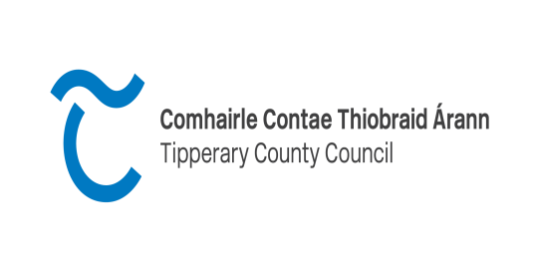 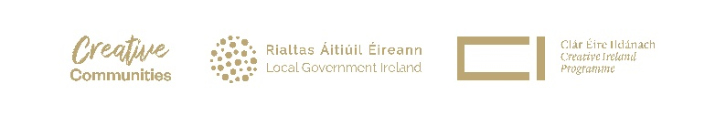

**TIPPERARY CREATIVE IRELAND**

**PROJECT AWARD**

**2025**

|  |  |  |  |
| --- | --- | --- | --- |
| Applicant Details | | | |
| Name of Organisation |  | | |
| Address of Organisation |  | | |
| Contact Person for the purpose of this application | | | |
| Name: |  | | |
| Telephone: |  | | |
| Email: |  | | |
| Details of Project/Event | | | |
| Title of Project |  | | |
| Aim of project |  | | |
| **Project Description: Please describe your project and clearly demonstrate how it will contribute to the Tipperary Creative Ireland Programme (use a separate sheet if necessary)** | | | |
|  | | | |
| Location of Project/Event |  | | |
| Date of Project/Event |  | | |
| Tipperary Creative Ireland Strategy  Please tick the box your project/event aims to promote (more than one can be selected) | | | |
| Our People’s Creativity | |  | |
| Our Creative Economy | |  | |
| Our Creative Place | |  | |
| Creative Climate Action | |  | |
| What is the expected community benefit from this project | | | |
|  | | | |
| How will you promote the project/event: |  | | |
| Please demonstrate your capacity to deliver this project/event (e.g previous experience in similar projects etc) | | | |
|  | | | |
| Have you secured any approvals, permissions, licences or consents necessary for your project, please provide details |  | | |
| Is your group a member of Tipperary Public Participation Network (P.P.N) YES/NO |  | | |
| Costs/Budget  Please give details of all your project costs (**copies of quotations should be included separately)** | | | |
| |  |  | | --- | --- | | **Income**: *Please list own resources, other grant funding or projected income if there is a charge for your event* | **Amount** | |  |  | |  |  | |  |  | |  |  | |  |  | | Total |  |  |  |  | | --- | --- | | **Expenditure:** *Please list all project costs* | **Amount** | |  |  | |  |  | |  |  | |  |  | |  |  | |  |  | |  |  | | Total |  |   Please use additional page if necessary | | | |
| Total Cost of Project | | |  |
| Total Amount sought from Creative Ireland | | |  |
| Have you received funding from any other sources | | |  |
|  | | | |

I have read the guidelines and understand the conditions of this funding and agree to comply in full with same. I declare that all information provided on this funding application and any additional information supplied is accurate and complete and I have not applied to any other Local Authority for funding of this project/event.

Name:**_______________________________________________**

Signature**: ___________________________________________**

Role in organisation___________________________________________

Date:___________________________________

Deadline for submissions is **4pm** on **Thursday 30th January 2025.**