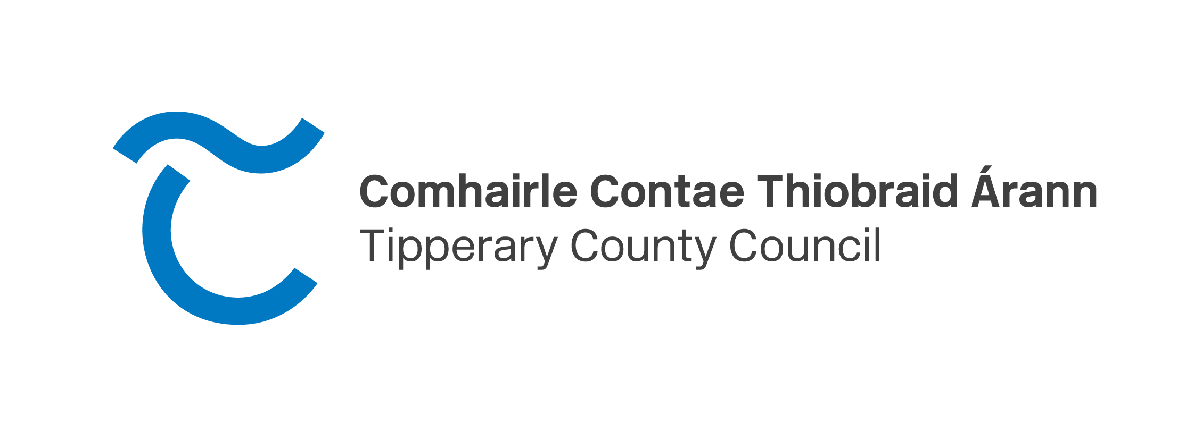

**Press release – 23/10/2024**

**New Town Team for Thurles**

A new Town Team has been established in Thurles to support the formation and delivery of a new Town Centre First Plan for the town.

The new Town Team had their first meeting in July and is made up of business people, community representatives and other key stakeholders who represent diverse sectors and backgrounds. The new Chair of the Town Team is Caroline Nesbitt, managing director of Thurles based graphic design consultancy company “Designedly”. The Town Team consists of local people who have come together to make their town a better place to live, work, visit and invest in. They will work in collaboration with Tipperary County Council and Local Representatives to support the delivery of the Thurles Town Centre First Plan once it is finalised.

The plan will guide the regeneration of the town and provide the basis for future funding applications by the Local Authority. For the plan to best fit the needs of the town and those who live and work in it, the Draft Plan will be made available for submissions on the Council’s website.

The Town Centre First policy was launched by the government in 2022 and it aims to create town centres that function as viable, vibrant and attractive locations for people to live, work and visit, while also functioning as the service, social, cultural and recreational hub for the local community. As a result, Tipperary County Council is working with Town Teams around the county to create Town Centre First Plans for towns and villages.

Funding for this Plan is in place and work has commenced to appoint a team of consultants to work with the Town Team to prepare a Town Centre First Plan for Thurles. As the consultants reach the final stages in mapping out the vision and objectives for the regeneration of the town there will be public consultation to ensure that residents have the opportunity to make a submission on the plan for Thurles.

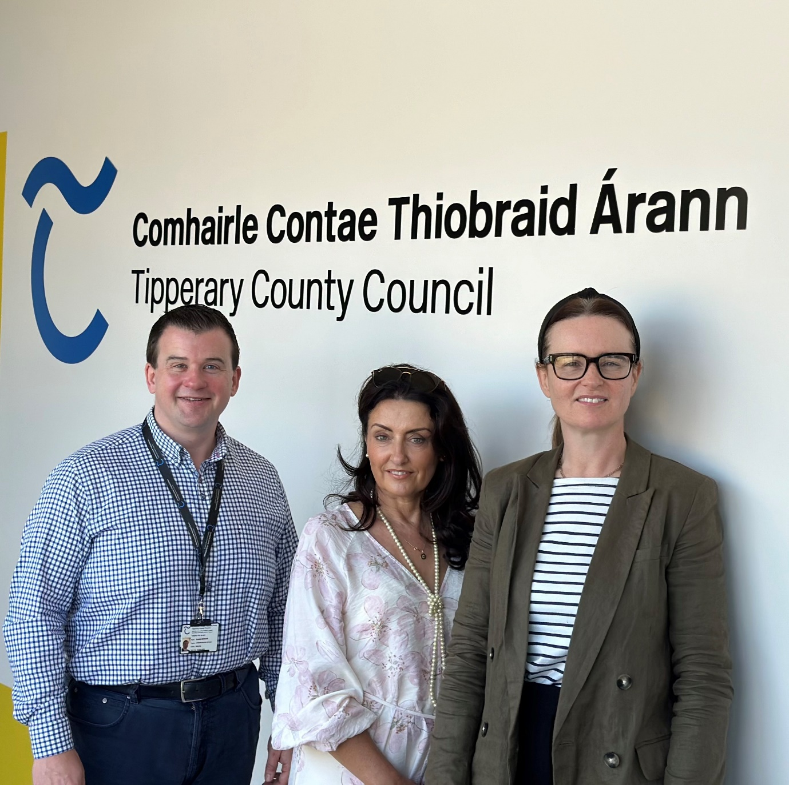

Figure Shane Grogan (TRO), Caroline Nesbitt (Town Champion) and Sharon Scully (District Administrator - Thurles MD)

We would like to invite you to complete the attached survey and submit to [tcf@tipperarycoco.ie](mailto:tcf@tipperarycoco.ie)

(link to pdf “survey questions Thurles”)