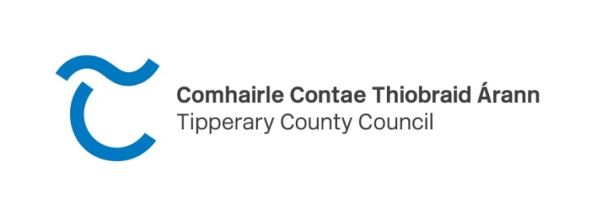
CLÁR Funding 2022
Expression of Interest Form (note closing date for submission is 12 Noon) Wed 30th March 2022 at 12 noon
Measure 1: Developing Community Facilities & Amenities
Please refer to the Department of Rural & Community Development Website for the Scheme outline at Clár 2022
Applications can only be submitted from these DEDs for CLÁR funding:
South Tipperary
DED ID | DED NAME | DED ID | DED NAME |  | DED ID | DED NAME | DED ID | DED NAME
23091 | Kilmurry | 23123 | Coolagarranroe |  | 23147 | Kilcooly | 23164 | Emly
23092 | Newtown | 23126 | Kilcoran |  | 23149 | Modeshil | 23165 | Glengar
23097 | Clogher | 23128 | Newcastle |  | 23152 | Poyntstown | 23169 | Kilmucklin
23100 | Clonoulty West | 23131 | Tullaghorton |  | 23155 | Ballykisteen | 23170 | Lattin
23102 | Cooleagh | 23136 | Killaloan |  | 23157 | Bruis | 23171 | Rathlynin
23103 | Drangan | 23141 | Ballingarry |  | 23158 | Cappagh | 23172 | Rodus
23107 | Graystown | 23142 | Ballyphilip |  | 23159 | Clonbeg | 23173 | Shronell
23118 | Ballybacon | 23143 | Buolick |  | 23160 | Cullen | 23174 | Sologhodbeg
23119 | Ballyporeen | 23144 | Crohane |  | 23161 | Curraheen | 23175 | Templeneiry
23120 | Burncourt | 23145 | Farranrory | 23162 |  | Donohill
23122 | Clogheen | 23146 | Fennor | 23163 |  | Drumwood
North Tipperary
DED ID | DED NAME | DED ID |  | DED NAME |  | DED ID | DED NAME |  | DED ID | DED NAME
22005 | Aglishcloghane | 22019 |  | Rathcabban |  | 22043 | Kilnarath |  | 22065 | Foilnaman
22006 | Ballingarry | 22020 |  | Redwood |  | 22046 | Latteragh |  | 22066 | Glenkeen
22007 | Ballylusky | 22023 |  | Uskane |  | 22050 | Templederry |  | 22067 | Gortkelly
22009 | Carrig | 22024 |  | Abington |  | 22052 | Borisnafarney |  | 22072 | Longfordpass
22010 | Cloghjordan | 22025 |  | Aghnameadle |  | 22053 | Borrisnoe |  | 22074 | Moyaliff
22011 | Cloghprior | 22028 |  | Ballygibbon |  | 22054 | Bourney East |  | 22076 | Moyne
22012 | Clohaskin | 22029 |  | Ballymackey |  | 22055 | Bourney West |  | 22078 | Templetouhy
22013 | Finnoe | 22036 |  | Dolla |  | 22056 | Killavinoge |  | 22081 | Upperchurch
22014 | Graigue | 22040 |  | Killoscully |  | 22057 | Killea |  | 22701 | Greenhall(037)/ Lackagh(045)
22016 | Lorrha East |  | 22041 | Kilmore | 22058 |  | Rathnaveoge
22018 | Mertonhall |  | 22042 | Kilnaneave | 22060 |  | Timoney

Please note: It is important that this Form is completed fully and accurately and that any additional/supplementary information required is also supplied at the time of submission.
Project Information
Project Name:
Community/School/Local Authority Project Name:
Community/School Contact Person:
School Roll Number if applicable:
Community/School Address:
Community/School Contact Telephone Number:
Community/School Contact Email Address:
How long has your community/School been in operation (must be minimum 5 years as per guidelines)
Location/details of proposed works
DED Name:
DED ID Number:
NB must be from list provided of eligible DEDs above
Detailed Description of works proposed:

Rational/need for the works:

- Outline how many of the Sustainable Development goals this project will deliver upon?

See https://www.un.org/sustainabledevelopment/sustainable-development-goals/

- Outline how this project will positively deliver on each of the Sustainable Development Goals you highlighted in A.

Are these works part of a larger project? (Y/N) - If yes, please provide details
Was an application in respect of this facility approved under CLÁR or any other scheme in the past 3 years? (Y/N)- If yes, please provide details.
Has an application for funding for this project been submitted to CLÁR or any other scheme or programme in the past 3 years? (Y/N)- If yes, please provide details.
Are all necessary permissions in place? (Y/N/NA)
Where necessary permissions are in place, is documentary evidence attached? (Y/N)
Where necessary permissions are not in place, please provide any relevant information.
Has evidence of ownership/lease been provided? (Y/N/NA)
The facility will be open to the public (Y/N)
Demonstrate how the facility is open to the public (note school facilities must be open to the public outside school hours)
Demonstrate how your proposal is disability friendly
Does your proposal develop/enhance access to unique heritage sites or natural beauty in the community – if yes, give details
Total cost of project: |  | €
% Match Funding being provided (minimum 10% of total project cost): |  | €
Has evidence of the availability of Match Funding been provided? (Y/N)
Administration/Professional fees element of funding if applicable (not more than 10% of overall project cost) |  | €
Amount being sought under this CLÁR application |  | €
Is a full breakdown of the estimated cost attached? (Y/N)
If you wish to provide any additional information to support the application: Please complete the section below or attach separately.

Return form by post to CLÁR Scheme 2022, Community & Economic Development Section, Tipperary County Council, Ballingarrane House, Cahir Road, Clonmel, Co. Tipperary, or by email to CLAR@tipperarycoco.ie with CLÁR 2022 Scheme M1 by 12.00 noon on Wednesday 30th March 2022

